TITLE OF THE DOCUMENT

AUTHOR(s)

DATE

HORIZON 2020 - INFRADEV-4-2014/2015:
Grant Agreement No. 654119
PARTHENOS
Pooling Activities, Resources and Tools for Heritage E-research Networking, Optimization and Synergies

NAME OF THE DELIVERABLE

Deliverable Number | DX.X
Dissemination Level | [Choose a dissemination level]
Delivery date | DD Month 201X
Status | Draft/Final
Author(s) | Author 1  Author 2  Author 3  Author 4

Project Acronym | PARTHENOS
Project Full title | Pooling Activities, Resources and Tools for Heritage E-research Networking, Optimization and Synergies
Grant Agreement nr. | 654119

Deliverable/Document Information

Deliverable nr/title
Document title
Author(s)
Dissemination level/distribution

Document History

Version/date | Changes/approval | Author/Approved by
V 0.1 DD.MM.YY | Report main changes and addition here
V 0.5 DD.MM.YY
V 0.5a DD.MM.YY
V 0.9 DD.MM.YY
Final DD.MM.YY

Table of content
Executive Summary 6
1. CHAPTER ONE (Style: Title 1) 7
1.1. CHAPTER ONE – Section 1.1 7
1.1.1. Chapter one – Section 1.1.1 7
2. Use of Images and captions 7
2.1. Tables and color schemes 8
Conclusions 9
Appendix 1 – Template’s styles in plain text 10

Executive Summary
Text goes here

CHAPTER ONE (Style: Title 1)
This is chapter 1. You may want to use subsections within your chapters. Sections must be rendered with the Title 2 style.

CHAPTER ONE – Section 1.1

Chapter One – Section 1.1 uses bullet points. In order to format your bullet point correctly, please select the style
- Point 1
- Point 2
- Point 3

Chapter one – Section 1.1.1
Third level sub section.

Use of Images and captions
Your document will contain for sure several pictures, graphs or tables. This section shows you how the correct caption should be formatted.
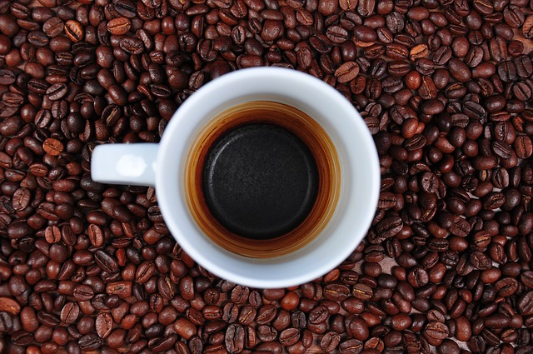
Figure 1 Time for a sip of coffee?
In general, as long as you use the present template, the correct style should apply to the different sections.
If not, please select it from the Styles menu (assuming you are using Word). If you are using other word processors, make sure you read the Appendix 1, which details all the different font and settings used.

Tables and color schemes
As you probably noticed, the dominant colors in PARTHENOS’ visual style are dark blue and azure. For your reference, the whole color palette is based on the two colors of the logo, displayed in the table below.
Table 1 PARTHENOS' basic colors. HEX code and RGB coordinates

Conclusions
This document is only used to show the different styles and the proper formatting in Word. For other softwares’ templates, please refer to our repository available at http://www.parthenos-project.eu/?page_id=167
The repository also contains the document “PARTHENOS Visual Style. Guidelines for an effective project dissemination”, which covers in details all the relevant FAQs regarding logo, use of the fonts and more. The reading of the document is strongly suggested for all partners.

Appendix 1 – Template’s styles in plain text
There are four main styles used in the document, plus the foot notes and captions. Those styles are
- Body: Helvetica (or Arial); font size 12pt; font color black, justify; line spacing 1,5pt
- Title 1 Helvetica (or Arial); font size 16pt; bold; CAPITAL; font color dark blue, Spacing 24pt before, 24pt after
- Title 2 Helvetica (or Arial); font size 16pt; bold; font color dark blue, Spacing 10pt before
- Title 3 Helvetica (or Arial); font size 12pt; bold; font color dark blue, no spacing before/after
- Quote Helvetica (or Arial); font size 12pt; italic, font color black; line spacing 1,5pt
- Bullet point: see Body
- Caption: Helvetica (or Arial); font size 10pt; bold; centered; font color black, Spacing 10pt after;

Contacts and questions
For questions and support with this template please contact stefano.sbarbati@pin.unifi.it

This is only to show the format of foot notes in the template

