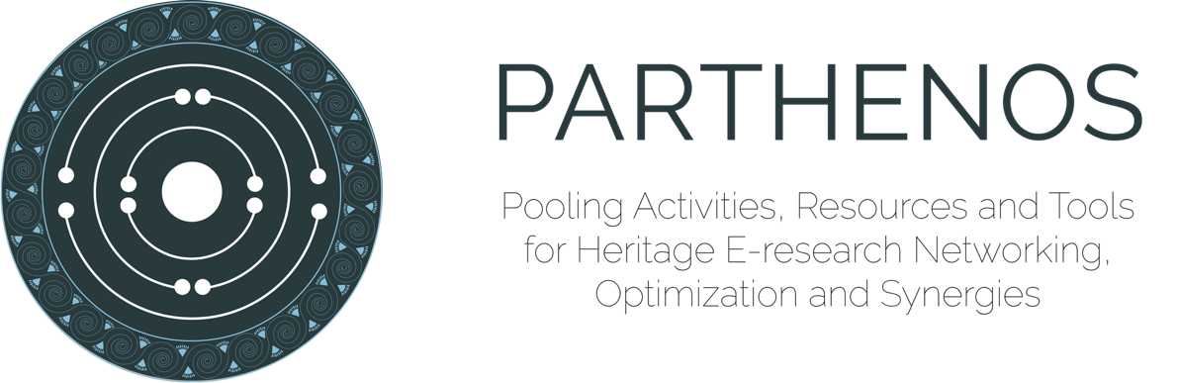

Licence conditions

The PARTHENOS Entity Model is released under a CC-BY-SA licence. It is intended that the PARTHENOS products were created for the benefit of research and society. Under no circumstances may they be reused for illegal or immoral purposes. Each product is made available “as is”, with no particular guarantee of functionality.

Attribution must be given to the following authors:
George Bruseker, Martin Doerr and Maria Theodoridou, ICS-FORTH.

Credits must also be given to the PARTHENOS project (as above) and the European Commission (as below).
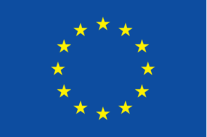

The PARTHENOS project was funded by the European Commission
(Grant Agreement 654119) within the H2020 Framework Programme.

